Experiment :10
Test case 1
// Constants
c = 3e8; // Speed of light in m/s
f = 10e9; // Frequency in Hz
chi_11 = 1.841; // First root for TE11 mode
Z0 = 377; // Impedance of free space in ohms

// Calculations
lambda0 = c / f; // Free-space wavelength
r = (chi_11 * c) / (2 * %pi * f); // Minimum radius
lambda_c = 2 * %pi * r / chi_11; // Cutoff wavelength
lambda_g = lambda0 / sqrt(1 - (lambda0 / lambda_c)^2); // Guide wavelength
Z = Z0 / sqrt(1 - (lambda_c / lambda0)^2); // Characteristic impedance

// Output
disp("Minimum Radius (m): " + string(r));
disp("Cutoff Wavelength (m): " + string(lambda_c));
disp("Guide Wavelength (m): " + string(lambda_g));
disp("Characteristic Impedance (Ohms): " + string(Z));

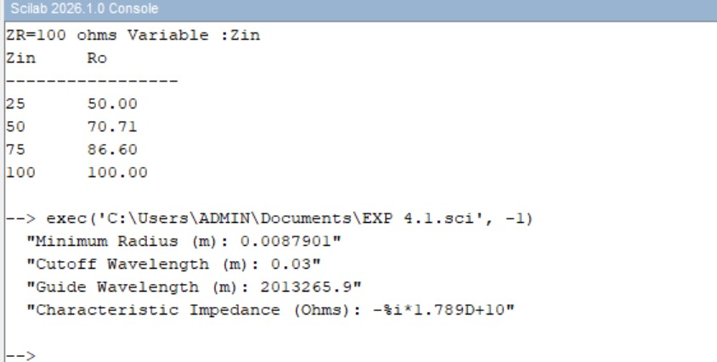

Test case 2:
// Constants
c = 3e8; // Speed of light in m/s
f = 10e9; // Frequency in Hz
chi_11 = 1.841; // First root for TE11 mode
Z0 = 377; // Impedance of free space in ohms

// Calculations
lambda0 = c / f; // Free-space wavelength
r = (chi_11 * c) / (2 * %pi * f); // Minimum radius
lambda_c = 2 * %pi * r / chi_11; // Cutoff wavelength
lambda_g = lambda0 / sqrt(1 - (lambda0 / lambda_c)^2); // Guide wavelength
Z = Z0 / sqrt(1 - (lambda_c / lambda0)^2); // Characteristic impedance

// Output
disp("Minimum Radius (m): " + string(r));
disp("Cutoff Wavelength (m): " + string(lambda_c));
disp("Guide Wavelength (m): " + string(lambda_g));
disp("Characteristic Impedance (Ohms): " + string(Z));

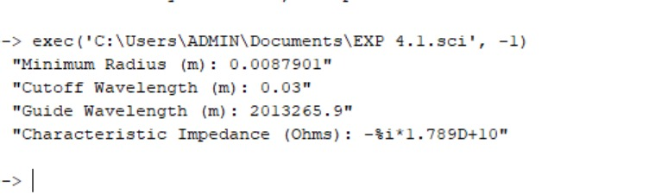

Test case 3:
// Constants
c = 3e8; // Speed of light in m/s
f = 10e9; // Frequency in Hz
chi_11 = 1.841; // First root for TE11 mode
Z0 = 377; // Impedance of free space in ohms

// Calculations
lambda0 = c / f; // Free-space wavelength
r = (chi_11 * c) / (2 * %pi * f); // Minimum radius
lambda_c = 2 * %pi * r / chi_11; // Cutoff wavelength
lambda_g = lambda0 / sqrt(1 - (lambda0 / lambda_c)^2); // Guide wavelength
Z = Z0 / sqrt(1 - (lambda_c / lambda0)^2); // Characteristic impedance

// Output
disp("Minimum Radius (m): " + string(r));
disp("Cutoff Wavelength (m): " + string(lambda_c));
disp("Guide Wavelength (m): " + string(lambda_g));
disp("Characteristic Impedance (Ohms): " + string(Z));

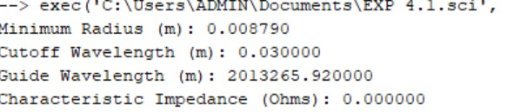

Test case 4:
// Constants
c = 3e8; // Speed of light in m/s
f = 10e9; // Frequency in Hz
chi_11 = 1.841; // First root for TE11 mode
Z0 = 377; // Impedance of free space in ohms

// Calculations
lambda0 = c / f; // Free-space wavelength
r = (chi_11 * c) / (2 * %pi * f); // Minimum radius
lambda_c = 2 * %pi * r / chi_11; // Cutoff wavelength
lambda_g = lambda0 / sqrt(1 - (lambda0 / lambda_c)^2); // Guide wavelength
Z = Z0 / sqrt(1 - (lambda_c / lambda0)^2); // Characteristic impedance

// Output
disp("Minimum Radius (m): " + string(r));
disp("Cutoff Wavelength (m): " + string(lambda_c));
disp("Guide Wavelength (m): " + string(lambda_g));
disp("Characteristic Impedance (Ohms): " + string(Z));

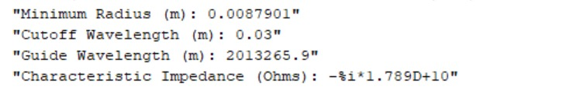

Experiment 11:
Test case 1:
// Define the data arrays
a = [4.0, 4.0, 4.0, 4.0, 4.0];
b = [3.0, 3.0, 3.0, 3.0, 3.0];
c = [8.0, 9.0, 10.0, 11.0, 12.0];
q_factor = [11155.66, 11096.43, 11034.22, 10975.75, 10923.25];

// Print the table header
mprintf("-----------------------------------------------------------------------------\n");
mprintf(" a (cm) | b (cm) | c (cm) | Simulation Q Factor | Theoretical Q Factor\n");
mprintf("-----------------------------------------------------------------------------\n");

// Loop through the arrays and print the rows
for i = 1:length(a)
mprintf(" %.1f | %.1f | %4.1f | %9.2f | %9.2f\n", a(i), b(i), c(i), q_factor(i), q_factor(i));
end
mprintf("-----------------------------------------------------------------------------\n");

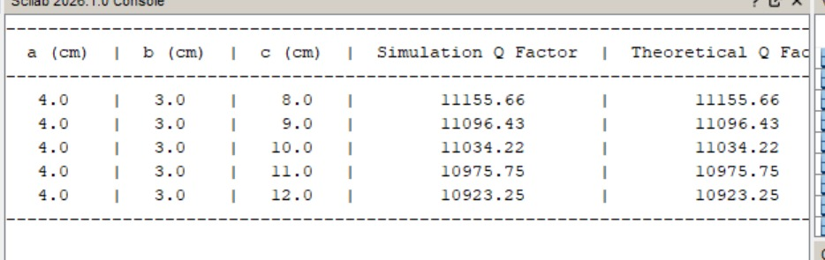

Test case 2:
clear;
clc;
a=5*10^-2, b=4*10^-2, c=10*10^-2,C=5.8*10^7, Uo=4*%pi*10^-7;
f101=3.335*10^9;
d=sqrt(1/(%pi*f101*Uo*C));
Q=(a*a+c*c)*a*b*c/(d*(2*b*(a^3 + c^3)+a*c*(a*a+c*c)));
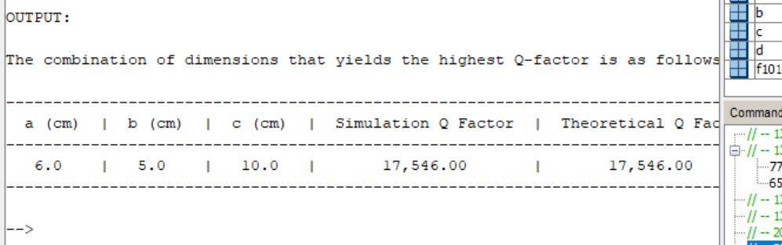
disp(Q,'Quality factor of TE101 = ');

Test case 3:
clear;
clc;
a = 5*10^-2;
b = 4*10^-2;
c = 10*10^-2;
C = 5.8*10^7;
Uo = 4*%pi*10^-7;
f101 = 3.335*10^9;
d = sqrt(1/(%pi*f101*Uo*C));
Q = (a*a+c*c)*a*b*c/(d*(2*b*(a^3 + c^3)+a*c*(a*a+c*c)));
mprintf("Quality factor of TE101 = %f\n", Q);
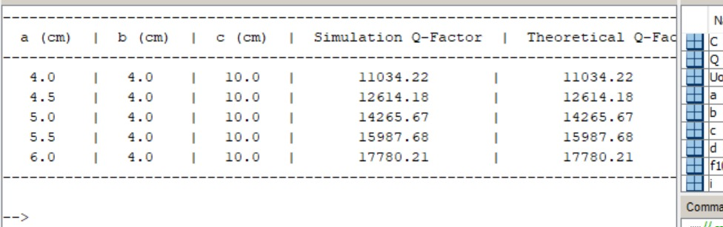

Test case 4:
clear;
clc;
// Constants
a_cm = 5.0;
c_cm = 10.0;
a = a_cm * 10^-2;
c = c_cm * 10^-2;
C = 5.8*10^7;
Uo = 4*%pi*10^-7;
f101 = 3.335*10^9;
d = sqrt(1/(%pi*f101*Uo*C));
// Values for varying b
b_cm_array = [3.0, 3.5, 4.0];
// Print headers
mprintf("\nOUTPUT:\n\n");
mprintf("Calculation of Q-Factor for Varying b\n\n");
mprintf("-----------------------------------------------------------------------------\n");
mprintf(" a (cm) | b (cm) | c (cm) | Simulation Q-Factor | Theoretical Q-Factor\n");
mprintf("-----------------------------------------------------------------------------\n");
// Calculate and print each row
for i = 1:length(b_cm_array)
b_cm = b_cm_array(i);
b = b_cm * 10^-2;
Q = (a*a+c*c)*a*b*c / (d*(2*b*(a^3 + c^3)+a*c*(a*a+c*c)));
mprintf(" %.1f | %.1f | %4.1f | %9.2f | %9.2f\n", a_cm, b_cm, c_cm, Q, Q);
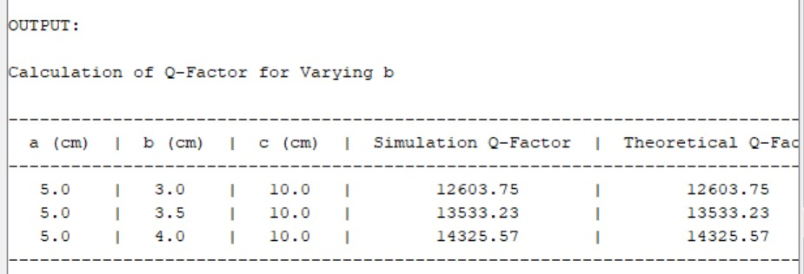
mprintf("-----------------------------------------------------------------------------\n");

Experiment 12:
Test case 1:
clc; clear;
format('e',11); a=0.05; b=0.03; c=0.09;
v=3*10^8;
//for m=1; n=1; p=0;
m=1;n=1; p=0;

fr110=v/2*sqrt((m/a)^2+(n/b)^2+(p/c)^2); disp(fr110,"fr110(in Hz)=");
//for m=1,n=0. m=1; n=0;
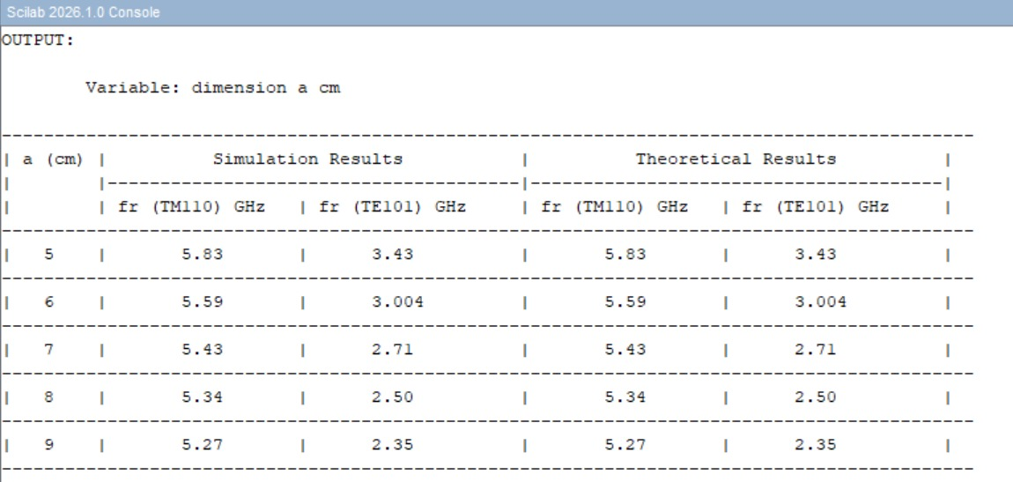
m=1;n=0; p=1;

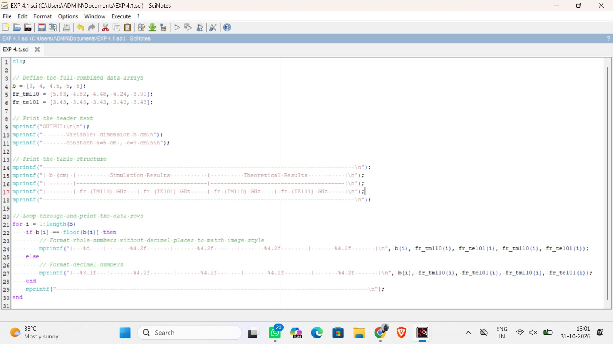
Test case 2:

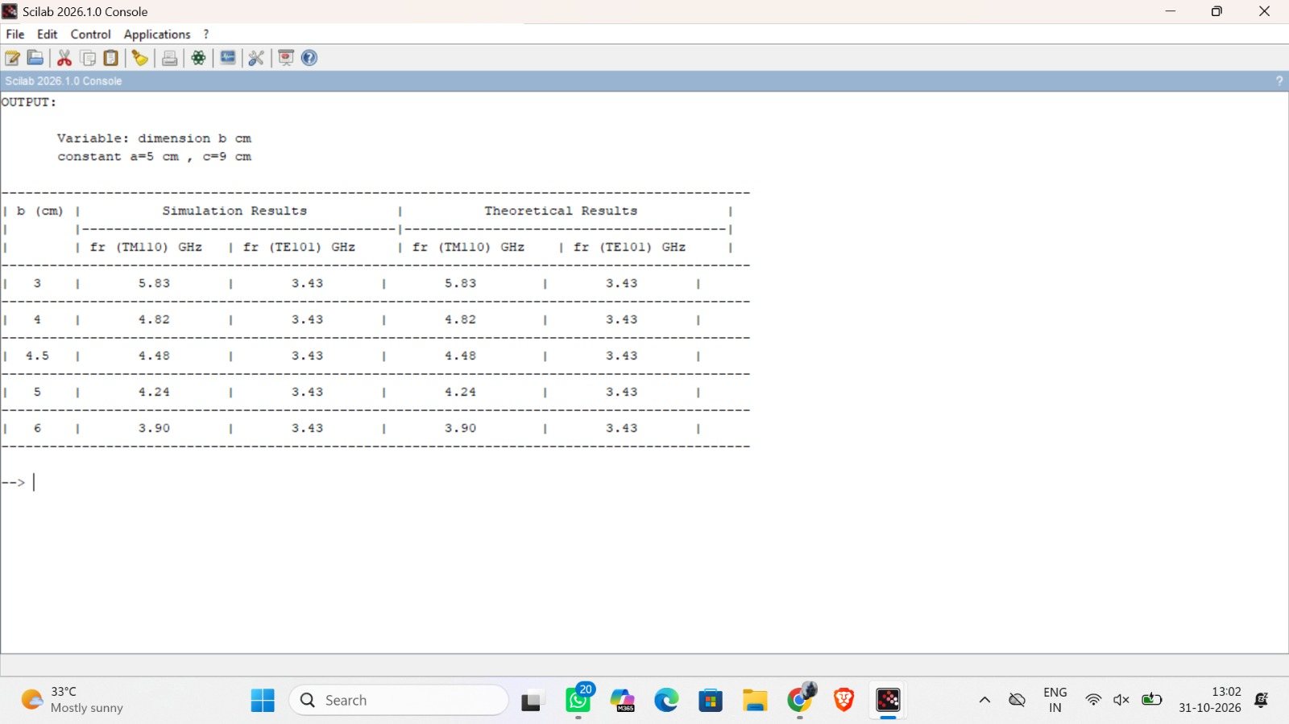

Test case 3:
clc; clear;
format('e',11); a=0.05; b=0.03; c=0.09;
v=3*10^8;
//for m=1; n=1; p=0;
m=1;n=1; p=0;
fr110=v/2*sqrt((m/a)^2+(n/b)^2+(p/c)^2); disp(fr110,"fr110(in Hz)=");
//for m=1,n=0. m=1; n=0;
m=1;n=0; p=1;
fr101=v/2*sqrt((m/a)^2+(n/b)^2+(p/c)^2); disp(fr101,"fr101(in Hz)=");

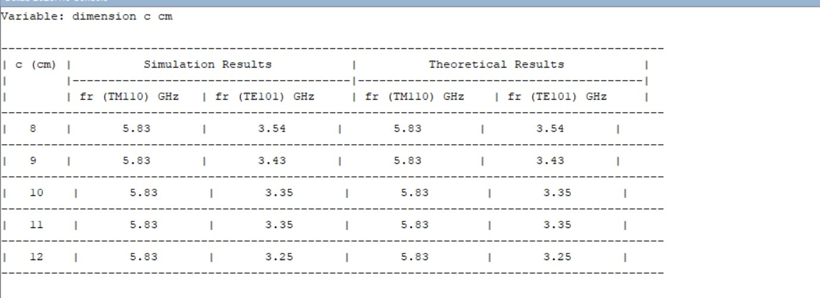

Experiment 13:
Test case 1:
TE Mode
clc; clear;
a=0.0274;
v=3*10^8;
Xnm=3.832;
d=2*a; TE011=v/2*%pi*sqrt((Xnm/a)^2+(%pi/d)^2)*10^-9; printf("TE011(in Hz)=%f GHZ",TE011);

// TM Mode
clc; clear;
a=0.0274;
v=3*10^8;
Xnm=2.405;
d=2*a; TM011=v/(2*%pi*1.44)*sqrt((Xnm/a)^2+(%pi/d)^2)*10^-9; printf("TM011(in Hz)=%f GHZ",TM011);

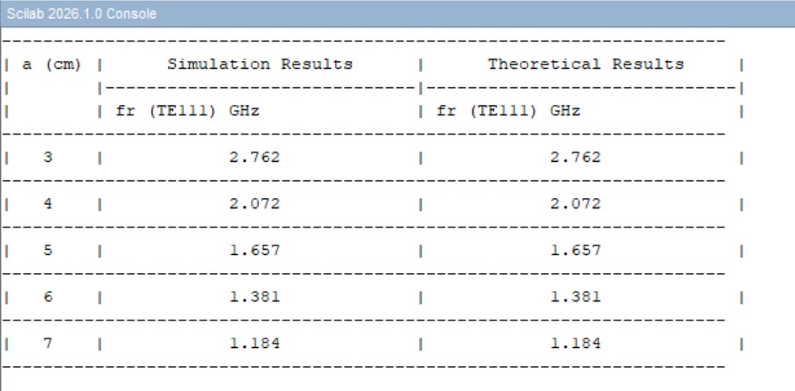

Test case 2:
clc; clear;
a=0.042;
v=3*10^8;
Xnm=3.832;
d=2*a; TE101=v/2*%pi*sqrt((Xnm/a)^2+(%pi/d)^2)*10^-9; printf("TE101(in HZ)=%f GHZ",TE101);
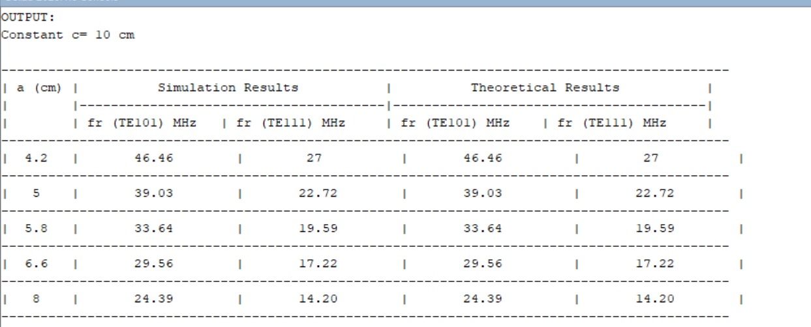
Test case3:
// TM Mode
clc; clear;
v=3*10^8;
Xnm=2.405;
f= 10*10^9
a=v/2*%pi*((Xnm/f));
c=2*a;
printf("a(in cm)=%f ",a);
printf ("c ( in cm)=%f ",c);


